新闻稿

旭格发布全新自动化窗式新风净化系统
中国上海，2016年12月6日 —— 近日，节能建筑外立面的全球领军企业德国旭格国际集团（以下简称“旭格”）推出应对当下环境多变的全新产品——自动化窗式新风净化系统VentoLife。该产品旨在防范居住环境中长期存在的各种空气问题和突如其来的恶劣气候所造成的影响。通过人性化的过滤系统设计，VentoLife能够最大限度地将外来和室内空气污染降到最低，保障室内人群空气安全指数达到最佳状态。
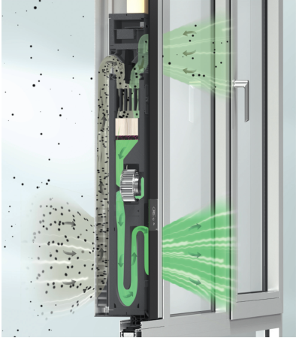
因为季节变化和工厂生产污染而产生的雾霾以及尘埃已成为人体健康的最大威胁，这也是旭格多年来一直关注的焦点。凭借在业界的尖端技术、个性化系统、领先的绿色节能概念以及建筑行业的专业知识，旭格特别开发了多层过滤网的新风净化系统VentoLife，专为满足大城市和人口密集区用户的各种需求。VentoLife让新鲜氧气无阻碍地通过滤网，同时有效阻挡粉尘、微粒及其他对人体有害的物质。不仅如此，即使在严重雾霾出现的情况下，VentoLife也能抵御最微小的空气颗粒物，除尘效率达到99.5%。在系统进行“空气循环”时，能使室外空气补给，随时保证建筑内空气质量达到优良水准。

系统结构，展示功能
大隐隐于“室”，灵活整合进窗系统，打造整体解决方案
VentoLife能无缝整合进窗或幕墙，在发挥净化系统的前提下不受房屋类别和使用目的的限制。它不仅能整合进旭格AWS 50至AWS 75 SI+窗系统系列（包括AWS BS.SI+隐扇系统），也适用于铝合金结构，通过安装外框的方式嵌入旭格FWS幕墙系统。可选择水平或垂直安装，提供安全省时的安装方式。无论哪一种类型窗体，VentoLife系统都能通过几近隐性的阴影接缝输送高质量的空气。此外，VentoLife的轮廓还可随意延伸，以便更好地与建筑相融合，可使用于学校、幼儿园、医院和养老院等。
旭格窗系统不仅提供前卫的功能和美观的外表，同时提升住宅舒适度，满足隔热、隔音、安防和自动化的最高要求，配合VentoLife可创造适宜的室内气候，提供极为舒适的居家和工作环境。
三重“铁布衫”，层层滤净雾霾灰尘
VentoLife的核心部分是超现代化的多层滤网。第一层褶皱紧密的静电驻极丙烯滤网极为坚固，保证长久的高效过滤。VentoLife能过滤空气中99.5%的PM 1.0颗粒物。第二层为活性炭与高锰酸钾混合滤网去除异味、细菌及有害物质，如氯炭化合物和臭氧等。第三层为颗粒吸附清洁滤网去除空气中的氨基酸和甲醛。
同时，VentoLife经过独立检测，达到极高的净化水准。更换滤网的频率为6-9个月不等，可根据运行时间和周围环境的空气污染程度来决定。更换滤网操作简单，无需任何工具。VentoLife不仅保障利于身体健康的优良室内空气质量，更是具有高性价比的系统运行模式。此外，用户可通过简明美观的显示面板和红绿黄三色发光条了解运行模式和室内空气质量。


图示：滤网设计和净化器

能效耗电全掌控，请叫我智能小管家
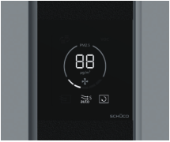
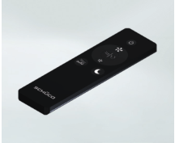
VentoLife的另一大亮点是拥有现代化高智能传感器，可计算“空气湿度”、“空气温度”、“微尘颗粒物指数”和“有机挥发物指数”，以最少的耗电量保障系统有效运行。人性化的内嵌室外空气换气阀可在自动运行模式下为室内补给必要的氧气，但在极端的恶劣天气条件下会自动关闭。在夜间会启动“自动安静模式”，控制通风机转数，从而减少不必要的噪音。这样在保证舒适睡眠的同时最大程度净化室内空气。

显示面板和遥控器
值得一提的是, 凭借创新的概念和卓越的品质在业内获得了无数良好的口碑,VentoLife十分荣幸地获得2016“最具创新力门窗幕墙系统”金轩奖。此奖项素有中国建筑门窗幕墙行业“奥斯卡”之称。
“VentoLife的创新设计大大提高了使用者室内的空气质量。除了普通的私人住宅和商务楼，我们认为对于学校、幼儿园、医院和养老院这样的人群是极其需要拥有一个良好的呼吸环境来加以保护。”旭格中国技术总监陈智旭先生表示，“旭格作为这个行业的领航者，拥有最前沿的技术。结合领先的绿色建筑环保理念以及雄厚的经验，使旭格在产品研发时总会将耐用、可靠、人性化等多重元素融入不同的产品，从实际出发为客户提供绝高品质的产品服务。”
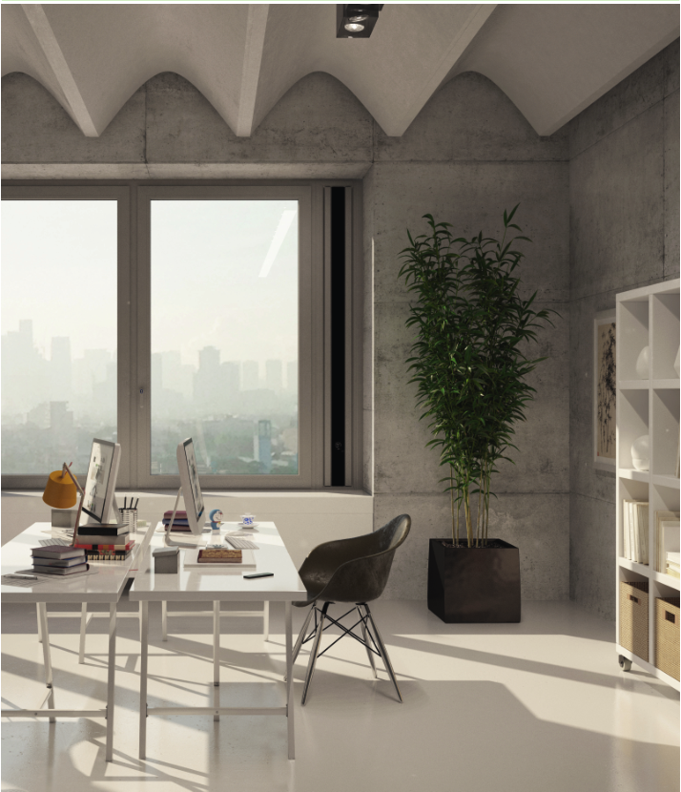

旭格 – 门、窗和幕墙系统解决方案的供应商
旭格 –门、窗和幕墙系统解决方案的供应商旭格与全球铝合金、PVC-U及电气合作伙伴、建筑师、开发商及投资商携手创造可持续发展的建筑外立面，以人为本，专注人、自然和科技的和谐统一。在满足设计、舒适及安全方面最高要求的同时，旭格铝合金和 PVC-U门、窗、幕墙系统通过节能降低碳排放，保护自然资源。公司为新建筑和翻新改造项目定制产品，满足各气候区用户的个性化要求，并在项目全程提供全方位的服务。旭格在全球 80多个国家拥有 4,630名员工和 12,000个合作伙伴。 2015年，集团的年销售额达到 14.30亿欧元。更多信息请访问 www.schueco.com.cn

需要了解更多信息，请联系：
旭格国际建材（北京）有限公司
电话：+86 21 61740066
传真：+86 21 61740136
邮箱：infocn@schueco.com

Press Release
6th ,December, 2016
Schüco Launches VentoLife Ventilation System
Shanghai, China, December 2016 – Recently, Schüco, a leading company in the field of sustainable building envelopes, launched its VentoLife Ventilation System, a brand new product designed to solve some current environmental problems, such as air pollution problems and problems caused by the sudden visits of atrocious weather. This human-oriented filtration system can minimize the effects of outdoor pollutants and indoor air pollution accumulation, ensuring ideal indoor air quality.
For many years, the reduction of smog and smoke which have become two of the most serious threats to human health has been a research focus of Schüco. VentoLife Ventilation System is specially developed by Schüco to meet the air purification demand of people in big cities and densely populated areas based on its industry leading technologies, personalized systems, advanced energy efficiency concepts, and professional architectural knowledge. VentoLife allows the smooth flow of fresh oxygen through the filters, while effectively blocking dirt, dust and other particles hazardous to human health. Even heavy smog will become powerless in front of VentoLife, for it can remove 99.5% of the dust in the air, including the smallest particles. The air circulation system of VentoLife purifies outdoor and indoor air to ensure high indoor air quality.

Construction of the façade to explain its function

VentoLife: An integration of air purification and windows
Since VentoLife can be seamlessly integrated into window and facade systems, its application will not be limited by the types and purposes of buildings. It can be integrated into a wide range of Schüco window systems from AWS 50 to AWS 75 SI+ (including AWS BS.SI+ window block series), and also aluminium alloy structures by being framed and embedded into Schüco FWS facade systems. VentoLife supports both vertical and horizontal installation in a safe and time-saving way. One of its advantages is that it can supply high quality fresh air through almost invisible shadow joints, in spite of the types of windows. Featuring edges that can be shaped as required by buildings, VentoLife is ideal for schools, kindergartens, hospitals and nursing homes.
Schüco window systems not only provide advanced functions and eye-pleasing appearance, but also satisfy the highest demands for comfort, thermal insulation, sound insulation, security and automation. Together with VentoLife, Schüco windows can create an ideal indoor climate and very comfortable living and working environments. Schüco window systems have been widely known for their high quality.
Three filters – leaving no place for dust
At the heart of Schuco VentoLife is a high-tech, multistage filter unit. The tightly pleated and electrostatically charged polypropylene membrane is extremely durable and ensures permanent high-performance filtration. This means that 99.5% of particles down to a size of just 1 μm are removed from the air. A layer made from an activated carbon-potassium permanganate compound eliminates troublesome smells, bacteria and toxic substances that are hazardous to health, such as chlorinated hydrocarbon and ozone. The sorptive granulate Clean-Pro also removes amino acids and formaldehyde from the air flow.
Independent tests have confirmed the high purification effect of Schuco VentoLife. Filters need to be replaced every 6-9 months according to the degree of air pollution, and the process of replacement is very easy without the participation of any tool. Producing high quality indoor air for human health in a cost-effective manner, VentoLife has a simple and nice-looking display panel which shows the operating mode and three (red, green and yellow) light bars that indicate indoor air quality.

Filter design and purification stages
Intelligent air quality manager – realizing energy efficient air purification
Another highlight of VentoLife is its highly intelligent sensors which can calculate “air humidity”, “air temperature”, “dust particle index” and “organic volatile index”, ensuring effective system operation with the lowest power consumption. Its human-oriented embedded outdoor air control valve allows indoor oxygen supply in the automatic mode, and turns off automatically in case of severe weather. The “night silent mode” will be activated automatically when night falls, reducing noise by slowing down fan rotation. In this way, users can enjoy comfort sleep while breathing in fresh air.

Display and remote control
The powerful functions and excellent quality of VentoLife have been proved by the National Fenestration Awards, the “Oscar Awards” for China’s door, window and façade manufacturers.
“The innovative design of VentoLife greatly improves indoor air quality. We think that compared with common residential and commercial buildings, schools, kindergartens, hospitals and nursing homes have more urgent demand for a healthy indoor environment with fresh air to breathe,” said Mr. Zhixu Tran, Technical Director of Schüco China, “Schüco as an industry leader has cutting-edge technologies, which, together with our green architecture concepts and abundant industry experience, create durable, reliable and human-oriented excellent products that perfectly satisfy the real needs of customers.”

Schüco – System solutions for windows, doors and façades
Together with its worldwide network of metal, PVC-U and electrical partners, as well as architects, specifiers and investors, Schüco creates sustainable building envelopes that focus on people and their needs in harmony with nature and technology. Metal and PVC-U window, door and façade solutions from Schüco meet the highest requirements in terms of design, comfort and security. At the same time, CO₂ emissions are reduced through energy efficiency, thereby conserving natural resources. The company delivers tailored products for newbuilds and renovations, designed to meet individual user needs in all climate zones. Everyone involved is supported with a comprehensive range of services at every stage of the construction process. With 4630 employees and 12,000 partner companies, Schüco is active in more than 80 countries and achieved a turnover of 1.430 billion euros in 2015. For more information, visit www.Schüco.com.cn

For more information, please contact
Schüco China
Tel：+86 21 61740066
Fax：+86 21 61740136
Email：infocn@Schüco.com

