源自“大恒”的传世承诺
Daheng – A Commitment that Lasts Forever
置身宝岛顶级豪宅，品味典藏臻品佳作
To Live a Luxury Lifestyle with Taste

由钜大恒坐落于有“文化城”之称的台湾台中市，深厚的文化底蕴、四季均舒的宜人气候，完美传承了古老的文化特色。作为设计界的典藏之作，由钜大恒占据了天时地利人和的地理位置，正对面的国美馆是台湾唯一的公立美术馆和国家级美术馆，美术馆以“深耕台湾、热爱台湾、了解台湾”为出发点，怀抱着对台湾的情感。大恒的侧面沿着远近闻名的绿园道，在设计上拥有别具一格的三面植树墙设计，并且总面积高达1982平方公尺，堪称目前亚洲最大的植生墙。不远处，闻名遐迩的诚品书店同样坐落于此。诸多艺术品的典藏、绿色植物的环绕、精英翘楚的聚集地，与遥首相望的由钜大恒起到了相辉呼应、一脉相承的风格理念。
Located in Taichung, a city in Taiwan known for its characteristic and fascinating culture and long history, as well as a balmy climate all the year round, Daheng developed by Yo Ji Construction represents a classic of architectural design. Boasting an excellent geographical location, it is just across the National Taiwan Museum of Fine Arts, the only public national-level art museum in Taiwan. Rooted in profound love for this land, this museum tries to explore into the past, present and future of Taiwan. Stretching beside Daheng is the famous Calligraphy Greenway which features three unique green walls covering an area of 1,982 square meters, the largest in Asia. Moreover, the renowned Eslite Bookstore is also in its proximity. The place where Daheng sits prides itself on the huge collection of art works, well-designed landscaping and irresistible attraction to social elites. Its style outside and concepts inside are just what Daheng owns and expresses.
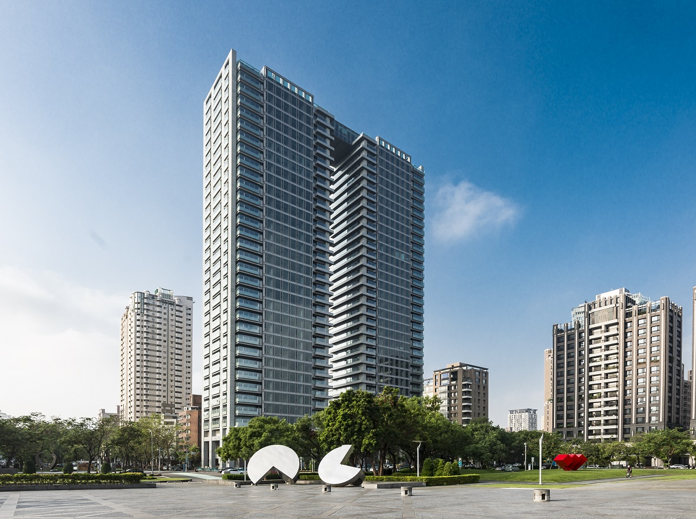
徘徊于经典与现实，东西方文化灵魂的完美碰撞
When classic meets modern, when the East meets the West

“大恒”的名字源自诗经,象征从现在到永远、承诺永远不变，也是业主给予客户的亘古祝福。
“Daheng” (eternity) originates from The Book of Songs, meaning a commitment that lasts forever, which is the right commitment of Yo Ji Construction to its clients.

大恒在设计上具有里程碑的意义，在宏伟设计的背后蕴藏着设计方、开发商等多年来的运筹帷幄和蓄势待发之势。在可媲美巴黎左岸的国美馆地区，该项目是开发商由钜建设珍藏50年之久的土地，终于在2016年，十年磨一剑，完成了由钜大恒。由钜大恒的总面积2742平方米，总高达到35层，双塔设计由顶楼互相连接。在寸土寸金的国美馆地区，大恒的面积已近似曼哈顿的面积。在周围建筑普遍不高的市西区，大恒高达35层高的双塔设计可谓鹤立鸡群，独一无二的地标性建筑。
A project that has been planned by the designer and developer for many years, Daheng marks a milestone in the design history of Yo Ji Construction . The National Taiwan Museum of Fine Arts area for Taiwan is like the Left Bank for Paris. The parcel on which Daheng stands was bought by Yo Ji Construction 50 years ago, and finally, in 2016, two towers over 2,742 square meters with linked top floors rise 35 stories above the ground. In this area where space comes at a premium, Daheng covers an area almost as large as Manhattan, and its 35-story twin-tower design makes it a unique landmark in the West District where super high rises are rarely seen.

大恒由台湾著名的李祖原联合建筑师事务所为之精心打造、量身定制。其创始人李祖原先生素以“中国风设计”而赫赫有名，是目前为数不多的坚持贯彻“中国式建筑”的设计师。受事务所的熏陶和传承，为大恒项目操刀设计的王重平建筑师不仅在当代建筑中积极体现中国传统文化的精神，并且不断探索东西方文化在更高层次上的契合。在设计理念上，大恒深入融合了东西方文化的精髓。王重平先生不禁感慨道：“即使是西方元素很浓厚的当代建筑，也需要大胆地融入东方文化的元素，这一点十分重要。因为建筑物质本身是阶段性的，但对于东方文化精神上的表达是具有永恒性的。”
Daheng is specially designed by C.Y. Lee & Partners whose founder C.Y. Lee, being far-famed for his “Chinese style design”, is one of the few designers insisting on designing “Chinese style architectures”. Mr. Z.P. Wang from C.Y. Lee & Partners is responsible for the design of Daheng. Following the traditions of C.Y. Lee & Partners, Wang tries to incorporate the essence of traditional Chinese culture into the design of modern buildings, and to realize the perfect fusion between eastern and western cultures. The design philosophy of Daheng contains the profound integration of the essences of eastern and western cultures. Wang once said, “The important thing is that we need to boldly incorporate the elements of Chinese culture into the design of modern buildings, no matter how western they are. And the reason is that buildings themselves only exist for a limited period of time, but the Chinese culture and ideas that they express will not die with their disappearance.”

精心打造高品质格局，打破传统的绝美设计
High quality and perfect creative design

大恒被赋予 “都市之玉”的美名，通透的墙面在夜晚如同都市里两块洁白无瑕的美玉。顶楼连体式的设计，不仅增强人们活动时的安全感，在夜晚月光与灯光的双重映衬下更犹如一个漂浮的透明八音盒。同时它也是小区的专属空中酒廊，让人神往之余更是令人赞不绝口。挑高10米的大厅在台湾住宅建筑中实属罕见，1到4楼的公共设施空间采用了独具匠心的错层设计，外加精心挑选的艺术品摆设于其中，俨然仿佛走进了艺术的殿堂。设计师的初衷就是希望藉由完美的设计以及绝高的品质，可以使客户将之视为绝世珍宝一般，代代相传。
With glass walls gleaming at night like two pieces of beautiful jade, Daheng is reputed as the “Jade in City”. The sky-bridge between the two towers, creating a sense of safety, looks like a floating transparent music box in the moonlight and lamplight. The bridge also acts as a bar, which is quite appealing thanks to its special design and location. Another highlight of Daheng is its 10-meter-high lobby which is very rare among residential buildings in Taiwan. Besides, the public spaces from the first to the fourth floor are designed with staggered floors, and decorated with selected art works which create a world of art. Pursuing high quality and perfect creative design, the designer wants to present a building as precious as treasures which can be passed down from generation to generation.
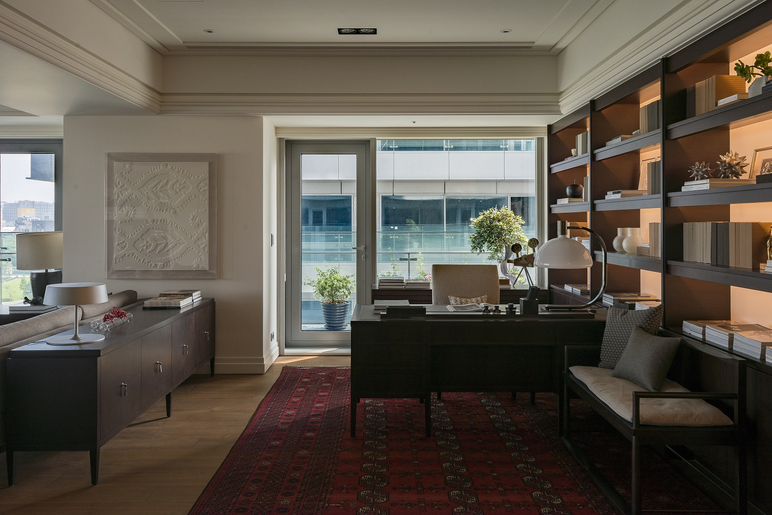

为了配合建筑外立面如美玉般的设计效果并满足客户的体验，由钜建设采用了旭格FW 60+ 、ADS 65 HD 、AWS 65 、AWS 102以及Unitized系列产品来完成门窗建筑和墙面设计，总面积约为16006平方米。其中，Unitized系列产品是旭格为大恒台湾项目特此设计开发。王重平先生特别提到，“最早用到旭格的产品是在淡水的颐海大院项目，只有旭格产品可以满足客户苛刻的要求，除了优质的隔音隔热功能，即使整面植栽墙经历了台风的洗礼，依然没有半点受损。过硬的质量和良好的口碑，使旭格成为不二之选。”
To create jade-like facades, Yo Ji Construction adopts Schüco FW60+, ADS65 HD, AWS 65, AWS102 and Unitized series in the door, window and facade design of Daheng for over an area of 16,006 square meters in total. Among those products, Unitized series are specially developed by Schüco for Daheng. When talking about Schüco, Z.P. Wang said, “Our cooperation with Schüco starts from the project of Yihai Compound in Danshui. We believe that only Schüco can meet the stringent requirements of our clients. In addition to excellent sound and thermal insulation performance, Schüco’s products have proved their excellent quality by preventing even the whole green wall from being damaged by a typhoon. We trust the quality and reputation of Schüco, and will keep cooperating with them.”
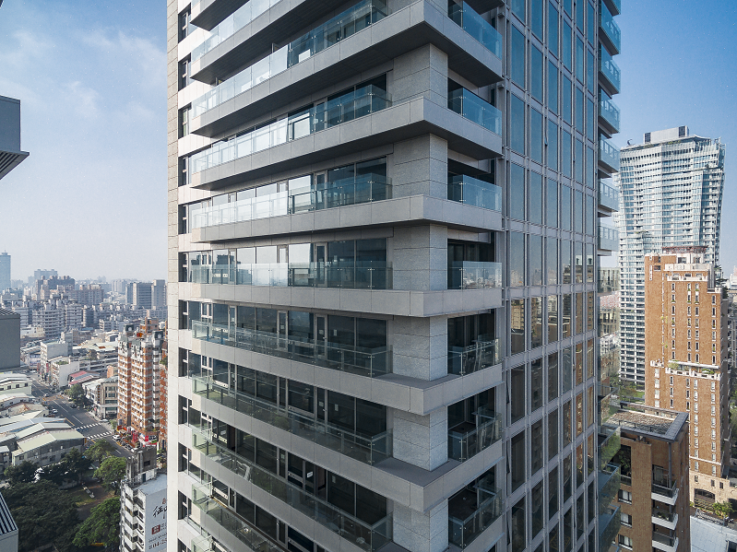
旭格是可持续发展建筑外立面领域的领军企业，素有高品质的门、窗和幕墙系统著称。如果一栋建筑由“骨”和“皮”构成，那么大恒在旭格的衬托下把空间的品质发挥到了极致。譬如阳台上前所未有的大面积玻璃墙使用，以及主卧和客厅的幕墙设计，使得设计师始终提倡的“安住生命，以人为本”的理念达到了完美呈现。
As a world leader in sustainable building envelopes, Schüco is known for producing high-quality door, window and facade systems which create excellent “skin” that covers the “bones” of buildings, so that the spaces of buildings are presented in a perfect way. For the case of Daheng, the unprecedented idea of enclosing balconies with large glass walls, and the wall design of master bedrooms and living rooms all show a good taste of spatial design, and best manifest the designer’ s idea of “Building for People”.

除了力争细节上的完美，大恒在创造性的工艺方面大胆寻求突破。旭格SimplySmart技术的连贯中间密封条已成功应用在型材结构深度为65 mm的系统，这意味着隔热水准要求一般的市场日后也可以从这项技术中获益。除了改进系统整体的隔热水准，还能保证更为简单、容错率更高的加工过程，大大节省加工件和安装时间。FW60+幕墙系统为加工和能效设定了新的标准，同时为设计师提供多样的设计选项。全新的系统可简化施工现场的加工流程，日后在新玻璃支撑件的帮助下能更轻松地加工极重的玻璃，并保持高水准的荷载转移性能。
In addition to pursuing perfect details, Daheng also seeks bold and creative breakthroughs in technologies. The concept of the continuous center gasket with Schüco SimplySmart technology is a tried-and-tested solution for Schüco window systems with 65 mm basic depth. As a consequence, markets with only average thermal insulation requirements can also benefit from this technology in the future. In addition to an optimization of the thermal insulation properties of the overall system, this also ensures that fabrication is even simpler and fault-tolerant with a considerable reduction in fabrication and assembly time. The Schüco Facade FW 60+ sets new standards of fabrication and energy efficiency, and also provides architects with a diverse range of design options. Thanks to this brand new system, fabrication processes at construction site will be simplified, and very heavy panes will be even easier to fabricate in the future owing to the new range of glazing supports, and will retain the same high level of load transfer.
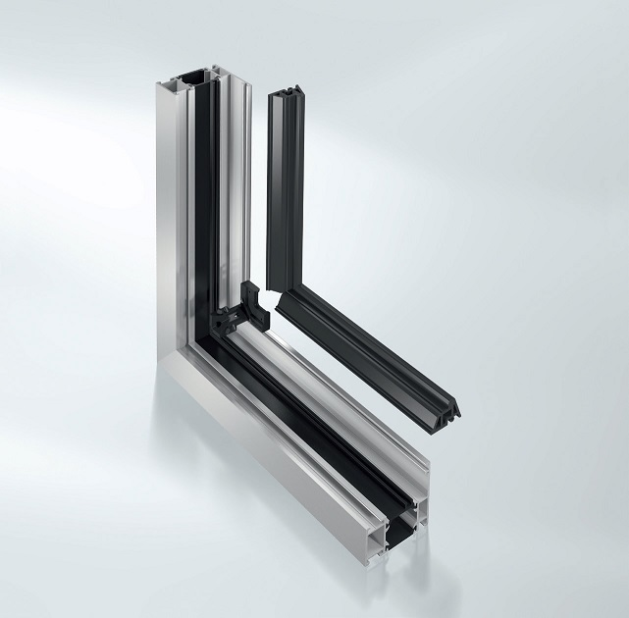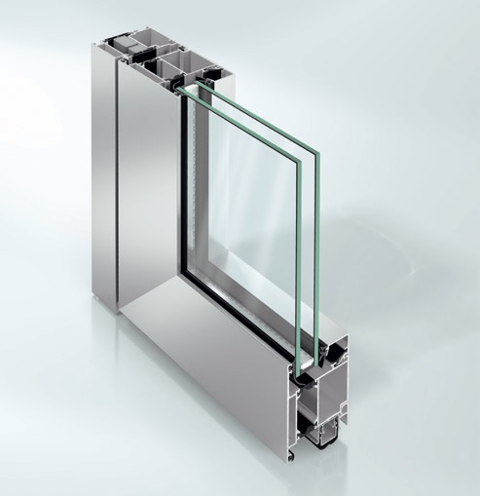
AWS 65 & ADS 70 HD
另外，考虑到台湾地理环境和气候特色，即使遇到超强台风、地震等不可抗拒的外在因素，经多次实践测试和考验，大恒的安全性可以做到无懈可击。这般超乎寻常的居住安定感，无可比拟的坚固与安全，使居住者有种沉浸于奢华之巅的悠然恰静以及唯美唯幻的城市生活。
Given the geographical conditions and climate characteristics of Taiwan, Daheng’s resistance to force majeure like super typhoons and earthquakes has been tested repeatedly to ensure a high level of safety, so that people living inside can enjoy a leisurely and luxury urban lifestyle in a safe environment.

王重平先生表示：“能够视为祖传之宝的东西一定是经的起岁月洗礼的不朽之作，由钜大恒的设计理念就是按照这样的标准去建造。大恒蕴含了东方传统文化之魂魄、西方现代理念之精髓加之如美玉般的穿透力，实属难得。令人欣慰的是旭格产品和由钜大恒的相辅相成，最终达到了非凡创新的效果。”
“We believe that a thing that can be passed down from generation to generation must be something extraordinary that can stand the test of time, and Daheng is such a thing. Daheng contains the essences of Chinese and western cultures, and presents a sense of transparency that comes from jade, which make it very unique and special. The cooperation between Schüco and Now & Forever has led to some great innovations in architecture,” said Z.P. Wang.

坐拥奢华之巅，品味不朽佳作
To Live a Luxury Lifestyle with Taste

打造了多个经典传世之作的李祖原联合建筑事务所，本身已创造了无数奇迹。例如，台北国际金融中心（台北101）、北京盘古大观以及高雄东帝士85国际广场等。王重平先生认为，只有建筑价值的不断提升，质量才会随之提高，从而强化建筑设计的竞争力。由钜大恒打破了住宅建筑的传统思维，不仅注入了艺术的典藏性、国际观，更是有传家的恒久性。大恒的收藏价值堪比传世珍宝一样稀有和与众不同。由钜大恒不仅给这座城市留下了经典建筑的印记，更提高了高端建筑的价值空间。不仅体现了入住者尊贵的社会地位，更是一种品味的共鸣。
A creator of classics, C.Y. Lee & Partners has worked many architectural wonders, like Taipei International Financial Center (Taipei 101), Pangu Plaza in Beijing, and 85 Sky Tower in Kaohsiung. According to Z.P. Wang, the quality of buildings increases with the constant increase of their value, and consequently, the competitiveness of designers is enhanced. Daheng breaks down the barriers placed by traditional ideas. It’s a piece of art, a building reflecting the international vision, and also a treasure that can be passed down over generations. Its scarcity and uniqueness give it the value to be collected as treasures. A classic architectural work in Taichung, Daheng increases the value of high-end buildings by showing the social status and good taste of people living inside.
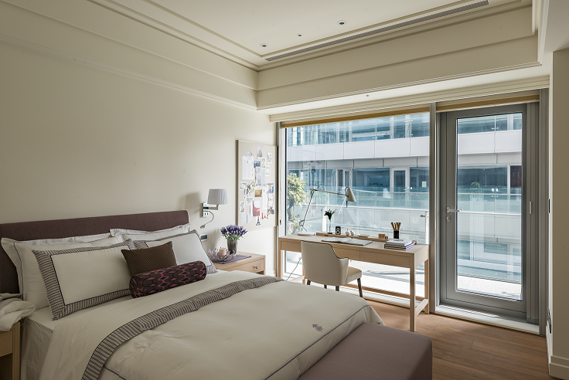
无与伦比的天然地理位置的优势，封存多年的稀有土地。大恒的每一个角落都回荡着大恒对客户的永恒承诺，这是一种灵魂的升华，更是人生新篇章的奏鸣曲。
Standing on a rare parcel boasting an unrivalled geographical location after years of preparation, Daheng is ready to fulfil its eternal commitment to the clients – a commitment to creating a space for spiritual growth and for the start of a new chapter of life.

旭格 – 门、窗和幕墙系统解决方案的供应商
Schüco – Supplier of window, door and façade system solutions
旭格 –门、窗和幕墙系统解决方案的供应商旭格与全球铝合金、PVC-U及电气合作伙伴、建筑师、开发商及投资商携手创造可持续发展的建筑外立面，以人为本，专注人、自然和科技的和谐统一。在满足设计、舒适及安全方面最高要求的同时，旭格铝合金和 PVC-U门、窗、幕墙系统通过节能降低碳排放，保护自然资源。公司为新建筑和翻新改造项目定制产品，满足各气候区用户的个性化要求，并在项目全程提供全方位的服务。旭格在全球 80多个国家拥有 4,630名员工和 12,000个合作伙伴。 2015年，集团的年销售额达到 14.30亿欧元。更多信息请访问 www.schueco.com.cn

Schüco – System solutions for windows, doors and façades
Together with its worldwide network of metal, PVC-U and electrical partners, as well as architects, specifiers and investors, Schüco creates sustainable building envelopes that focus on people and their needs in harmony with nature and technology. Metal and PVC-U window, door and façade solutions from Schüco meet the highest requirements in terms of design, comfort and security. At the same time, CO2 emissions are reduced through energy efficiency, thereby conserving natural resources. The company delivers tailored products for newbuilds and renovations, designed to meet individual user needs in all climate zones. Everyone involved is supported with a comprehensive range of services at every stage of the construction process. With 4630 employees and 12,000 partner companies, Schüco is active in more than 80 countries and achieved a turnover of 1.430 billion euros in 2015. For more information, visit www.schueco.com

需要了解更多信息，请联系：
旭格国际建材（北京）有限公司
电话：+86 21 61740066
传真：+86 21 61740136
邮箱：infocn@schueco.com

For more information please contact:
Schüco International (Beijing) Co., Ltd.
Tel: +86 21 61740066
Fax: +86 21 61740136
Email: infocn@schueco.com

